FDOH Polk County Travel Vaccine Questionnaire

 | Lakeland Travel Immunization Clinic  3241 Lakeland Hills Boulevard, Lakeland  Phone: (863)413-2620 Fax: (863)413-3163 | Bartow Immunization Clinic  1255 Brice Boulevard, Bartow  Phone: (863)519-8242 Fax: (863)519-8307
All travel vaccine visits require an appointment. Please completely fill out this form and fax to the travel clinic of your choice listed above. Also, please bring the completed form with you to your appointment.

IMPORTANT NOTICE
- Please bring all previous immunization records (or legible copies) with you to your initial visit.
- Travel vaccines are a very important tool in the prevention of viruses, illness and disease, specifically those associated with travel outside of the United States and Canada.
- In addition to routine immunizations such as Tetanus, Influenza (Flu) and Pneumonia, the CDC and World Health Organization (WHO) track common illnesses and outbreaks as they occur across the globe.
- The FDOH Polk County travel clinics use the latest recommendations from the CDC and the WHO in regards to providing you with information about vaccines and other forms of prevention.
- Related Links - **CDC's Travelers' Health website **International Travel web page on immunize.org
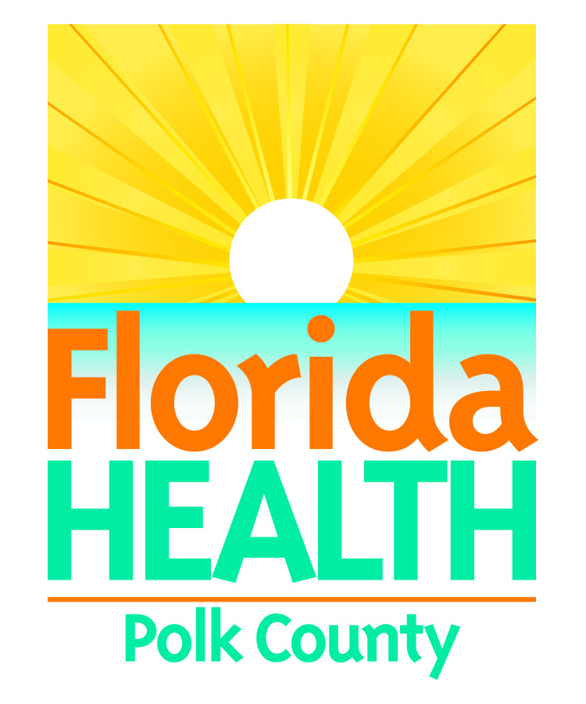
Today’s Date:
Patient’s Name (as it appears on passport or state issued ID):
Date of Birth:
Address:
Home Phone:
Work Phone:
Cell Phone:
Primary Care Provider:
Pharmacy of Choice:

TRAVEL ITINERARY INFORMATION
Many vaccinations and prophylactic treatments are dependent upon the actual regions and cities that you may be visiting. In order to help you best prepare for your travels as well as spare you any unnecessary costs, please give as much detail as you are able regarding your plans.

Date of Initial Departure: |  | Date of Return:
Destination | Method of Transportation |  | Length of Stay
Please bring a copy of your flight itinerary if possible.
Organization or Group Associated with Travel:
What will be the primary purpose of this trip:
Please describe in detail all that is known about your lodging and dining arrangements for this trip:
Patient’s Name: |  |  |  |  |  | Date of Birth:
Please list any current medical conditions:
Please list any current medications:
Please Circle your answer for the below questions:
Are there any medications to which you have had an allergic reaction? |  |  |  |  |  |  | Yes | No
If yes, Please list medications: |  |  |  |  |  | If yes, Please list type of reaction:
Have you ever had an allergic reaction to eggs, mercury (thimerosal), bee stings, formaldehyde, or sunlight? |  |  |  |  |  |  | Yes | No
Have you ever had a seizure, brain or nerve problem? |  |  |  |  |  |  | Yes | No
Are you currently being treated for leukemia, lymphoma, cancer, or any other type of malignant disease? |  |  |  |  |  |  | Yes | No
Do you have a known history of an incompetent immune system? |  |  |  |  |  |  | Yes | No
Do you have a history of anemia or any other known blood disorder? |  |  |  |  |  |  | Yes | No
Have you had any blood, blood products or IG in the past year? |  |  |  |  |  |  | Yes | No
Do you have a history of Guillain-Barre Syndrome? |  |  |  |  |  |  | Yes | No
Do you have a cochlear implant? |  |  |  |  |  |  | Yes | No
Are you currently taking any forms of steroids? |  |  |  |  |  |  | Yes | No
Do you have any spleen problems or have had a splenectomy? |  |  |  |  |  |  | Yes | No
Date of Last Menstrual Period: |  |  |  |  |  | N/A
What type of birth control do you use?
Are you pregnant? |  |  |  |  |  |  | Yes | No
Have you been on any antibiotic in the last 2 weeks? |  |  |  |  |  |  | Yes | No
If yes, Please List:
Have you had any vaccinations in the past 4 weeks? |  |  |  |  |  |  | Yes | No
If yes, Please List:
Have you ever had a serious reaction to a vaccine? |  |  |  |  |  |  | Yes | No
If yes, Please List:

Thank you for choosing the FDOH Polk County Health Department for your travel vaccines. We look forward to helping you plan for a safe trip.

